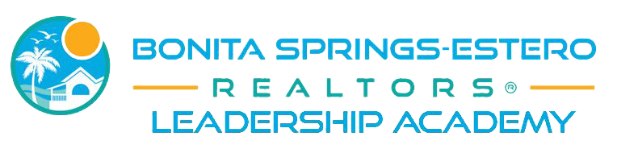
2020 CANDIDATE APPLICATION
Name:
Company:
Office Address:
Phone: Fax: Email:
Years in Real Estate: Board Member since MO/YR:
Primary Board Member: Y N MLS Member: Y N
Birth Date: Shirt Size: Dietary Notes:

PROFESSIONAL INVOLVEMENT –Board, Networking Groups, Etc.
COMMITTEE/TASK FORCE | DATES OF INVOLVEMENT | POSITION HELD

COMMUNITY INVOLVEMENT – Volunteer Groups, Chambers, Etc.
ORGANIZATION | DATES OF INVOLVEMENT | POSITION HELD

Why do you want to participate in the Bonita-Springs Estero REALTORS® Leadership Academy?

What concerns/suggestions would you have to offer to improve Bonita-Springs Estero REALTORS®

How would Leadership Academy improve your career? Membership value?

What education/experience are you seeking to gain from Bonita-Springs Estero REALTORS® Leadership?

REQUIREMENTS OF THE LEADERSHIP DEVELOPMENT PROGRAM
1. Commit to attending the program classes. Attendance is defined as full-session. Early out or late arrival will be counted as an absence. Any absence should be approved in advance. You will be ineligible to graduate if you miss more than 2 classes.
2. If you are not currently involved on a Bonita-Springs Estero REALTORS® Committee, you hereby agree to regular and consistent committee involvement commencing with the conclusion of this program.
3. You will be strongly encouraged/required to spend at least two (2) days at Great American Realtor Days in Tallahassee. The board will pay for hotel costs (room share) and will provide transportation. Cost of the registration is $50.
4. You will be required to participate in a Leadership Development Class Project which must be approved by the Leadership Committee.
6. You will be required to attend a pre-selection interview.
7. Although there is no tuition cost, you will be asked to purchase a leadership polo shirt to wear on our trip and modules. Cost of shirts will be $30.
8. If employed by an affiliate company, real estate admin or real estate team, please make sure that you have communicated with your employer to make sure that they are aware of your schedule.
9. Required to completed Leadership100 at no cost at nar.realtor prior to graduation.

SIGNATURE

I understand the purpose of Bonita-Springs Estero REALTORS® Leadership Academy and if I am selected, I will devote the time and resources necessary to complete the program.
I understand that attendance at the FR G.A.R. D. is highly recommended and I am expected at each session in order to graduate from the program; if I need to miss a session it is my responsibility to contact the chairperson prior to the session that will be missed. A maximum of two sessions may be excused. If a third session is missed I understand that I will not graduate from the program, and I will be expected to reimburse Bonita-Springs Estero REALTORS® for the FR G.A.R.D. trip expenses.

I understand that completion of this application does not guarantee a candidate’s acceptance into the Bonita-Springs Estero REALTORS® Leadership Academy.
All applicants will be notified of their status on or about December 20th.

I agree to these conditions and am committed to attend and participate in all program sessions:
Signature: ______________________________________________________Date: _________________

Please return completed applications to Meighan@bonitaesterorealtors.com by Dec 6th.
Although there is no tuition cost, you will be asked to purchase a leadership polo shirt to wear on our field trip, FR trip and meetings if desired. Cost of shirts will be $30. Please send a picture of yourself and a short bio to Meighan@BonitaEsteroRealtors.com
2020 LEADERSHIP SCHEDULE
Dec 10 & 11 Applicant Interviews
Dec 20th Applicants Notified
Jan 8th Introductory Class
Jan 22 Retreat - Salus Care
Classes will be held on Wednesdays from 9 am to 12pm – Some meetings will be held off-site and occasionally modules may run until 1 pm. Carpooling is encouraged. Dates are subject to change.
Feb 3-5 Great American Realtor Days – Tallahassee, FL
Feb 19 Module 1
Mar 4 Module 2
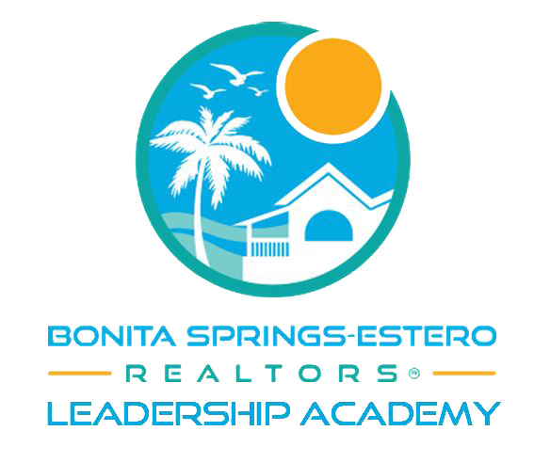
Mar 25 Module 3
April 8 Module 4
April 22 Module 5
May 6 Module 6
May 20 Module 7
June 10 Module 8
June 24 Module 9
July 8 Module 10
July 22 Module 11
Aug 5 Module 12
Aug 19 Module 13
Aug 26-28 Florida Realtors Convention & Expo (not required)
September 18 Graduation
*Class project and community outreach project will be held on a Saturday. Date TBD.

